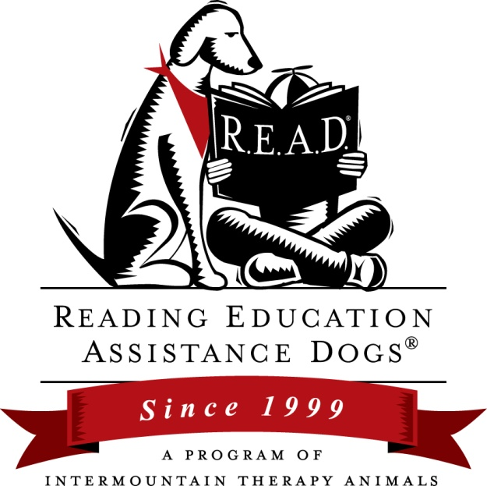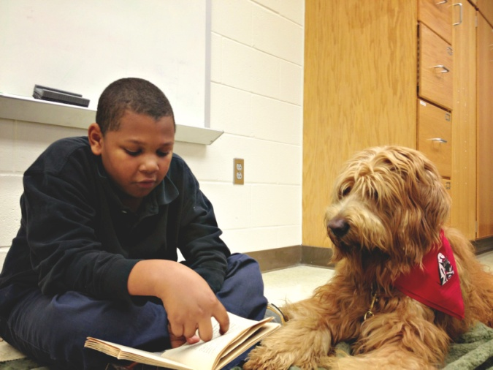

R.E.A.D.®
Training Workshop

Saturday, February 21st 2015
12:00 PM to 5:30 PM
at CARMEL OFFICE SUITES
600 E. Carmel Drive, Carmel, IN 46032
(Google Map: http://g.co/maps/f8wk8 )

Cost (including all training materials) is $65
If you already have a R.E.A.D. manual the workshop is $33

To register make checks payable to Paws and Think and send to:
Kathy Janes
3668 Tahoe Ct
Carmel, IN 46033
If you have any questions, contact Kathy Janes, kjanes@pawsandthink.org

In this workshop you will learn how to:
• Effectively conduct a reading session
• Successfully mentor young readers
• Set up a program in schools, libraries and other settings
• Help convince decision-makers in your community that R.E.A.D. works
• Help make reading FUN with different tools and techniques, and
• Benefit by becoming a registered R.E.A.D. member

This is a fast-paced, information-packed class for humans only. The emphasis is on what you need to know to organize and conduct a successful reading program. It is not a training class to teach your dog specific skills.

Workshop Facilitator
Kathy Janes
R.E.A.D. Instructor License # 077
kjanes@pawsandthink.org

Kathy enjoys a life-long love of reading and of dogs. She was excited when she discovered the R.E.A.D. program and a way to assure all of their organization’s therapy handlers had a sound educational base for their Paws to Read program. Since 2009 Kathy and her first partner, Mater, have been visiting local libraries, schools and bookstores throughout greater Indianapolis. Kathy credits her success to Mater, a very special Goldendoodle she and her husband Tom have raised and trained, and now Ozzie and Harriet as well.

Kathy began managing the therapy dog schedule for Paws and Think, Inc. in the spring of 2010. In January of 2011 she joined the Board of Directors. Since then her devotion to the work of the therapy dog has become a passion for her. In 2012 she worked to have Paws and Think, Inc. be recognized by the AKC, allowing members’ therapy dogs to earn their ThD. Title. At the same time she was determined to have Paws and Think become an affiliate of R.E.A.D.

Kathy became the first licensed R.E.A.D. instructor in Indiana in August of 2013. She is thrilled that she will be able to bring R.E.A.D. workshops to therapy teams across the state and region.

Professionally, Kathy is a project manager with over 15 years experience implementing products and process improvements for an international telecommunications company.
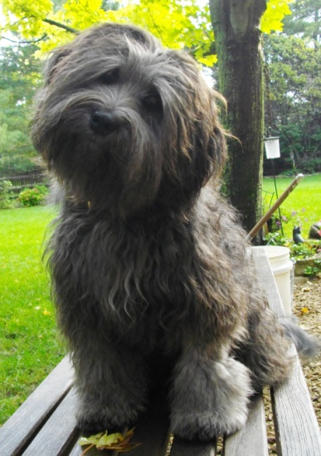
Ozzie Harriet Mater

